

Quality Center User Guide for Testers

Document Owner: Quality Assurance Team

REVISION HISTORY
VERSION NO. (Must match header) | DATE | REVISED BY | DESCRIPTION
1.0 | 12/14/2016 | Nancy Strouse | Document was created.
1.1 | 12/16/2016 | Kamal Aboueljoud | Review and Update
1.2 | 2/22/2017 | Kim Launer | Review and Update
1.3 | 2/23/2017 | Christopher McIntosh | Review and Update
1.4 | 4/03/2018 | Kamal Aboueljoud | Review and Update
1.5 | 1/15/2020 | René Dupré | Reformat document
1.6 | 1/16/2020 | Kamal Aboueljoud | Clarify Test Case execution process.
1.7 | 1/31/2020 | René Dupré | Addition of clarifications.
1.7.1 | 2/12/2020 | Kim Launer | Minor clerical updates. Added a reference to the Test Management Guidelines in section 5.5.
1.7.2 | 2/12/2020 | Kamal Aboueljoud | Minor and final updates.
1.7.3 | 4/10/2020 | Kim Launer | Updated section 5.4 to include example of step controls.
1.7.4 | 10/9/2020 | René Dupré | Updated all references to HPQC or ALM to “”.
1.7.5 | 10/23/2020 | Harleen Kaur | Added field Defect Type in 5.5 Defects
1.7.6 | 2/10/2021 | René Dupré | Added Compliance note to 5.5.1.

Contents
1.0 Introduction 4
2.0 Quality Center Application Access 4
2.1 How to Install Qualit Center 5
2.2 How to Log into Quality Center 5
3.0 Quality Center Application Toolbar 7
4.0 Quality Center Screens 9
5.0 Quality Center Testing Tasks 11
5.1 Creating a Test Plan 11
5.2 Uploading a Test Case 12
5.2.1 Uploading a Test Case Using the Test Case Template 12
5.2.2 Create a Test Case Manually 15
5.3 Preparing for Test Execution – Link Requirements 19
5.4 Executing Tests in the Test Lab 23
5.5 Defects 30
6.0 Dashboard 37
6.1.1 Analysis View 37
6.1.2 Dashboard View 37

Introduction

The Quality Center application is a software tool that allows users to upload business and system requirements, create test cases, track test cases, create and collect defect information. This document has been structured specifically for use by the testers in the ISO.

Quality Center Application Access

To access Quality Center, users must complete and submit the HPQC access request form from the eCurrent Help Center.

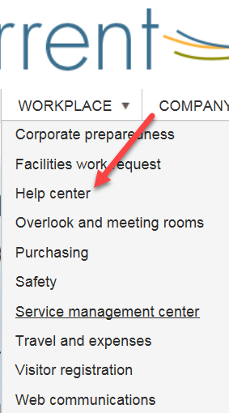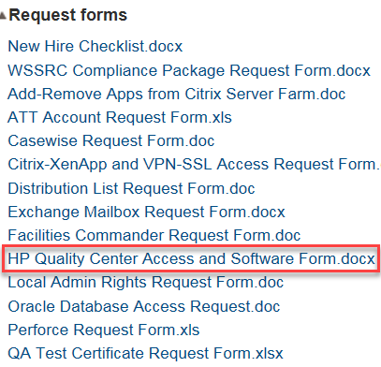

 | Note: Your manager will receive a Service Management Ticket they must approve. Thereafter, Quality Assurance will create an account which will allow you to log in.

How to Install Qualit Center

Click link to Quality Center which will load the application web page and then prompt to install plug-ins necessary to use the application. To install the Quality Center software, click Install.

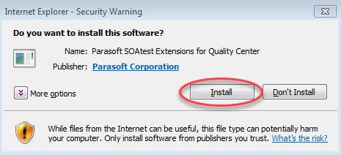

How to Log into Quality Center

Note that you need to authenticate and then select a project. Log in by entering your Windows username and password. Click Authenticate.

The Domain DEFAULT and Project MRTU will appear. Click Login.

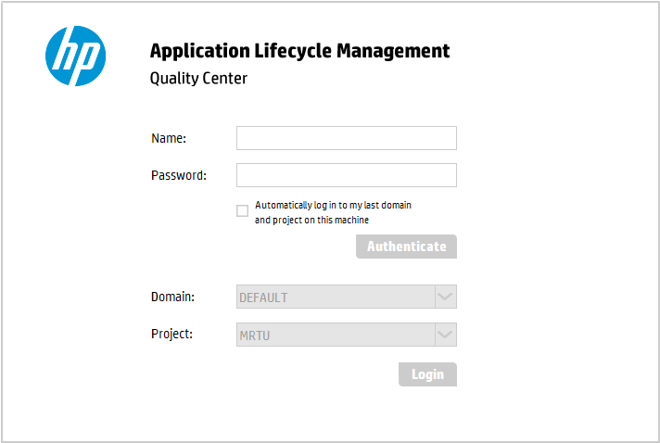

Note: When your Windows password is changed on your computer, your corresponding Quality Center password will automatically update.

Once logged in, a tutorial window will appear. Click X or Close to return to the application.

Quality Center Application Toolbar

It is helpful to familiarize yourself with the application toolbar as many functions are hidden within them. The application toolbar contains functions for navigating and performing actions which are outlined below. Hover over the tool to view the function and click to choose.

Quality Center Application Toolbar
Tool | Tool Name | Function
 | New Folder | Create a new folder
 | New Defect | Create and add details to a new defect
 | New Requirement | Create a new requirement
 | Delete | Delete test cases (administrator only)
 | Refresh All | Refresh the display in the current window
 | Set Filter/Sort | Set the filter and sort; clear the filter
 | Sort Folders | Sort folders by selected view
 | Select Columns | Select specific column information
 | Defect Details | Defect Details window
 | Attachments | Attach a file
 | Flag for Follow Up | Mark the file with a flag
 | Send by E-mail | Send results via e-mail
 | Find Similar Defects  Find Similar Text | Locate similar text
 | Text Search | Search text by keyword
 | Requirement Details | View and edit requirement details

Quality Center Screens

The Quality Center screen views are sorted in tabs under the left column of the home screen.

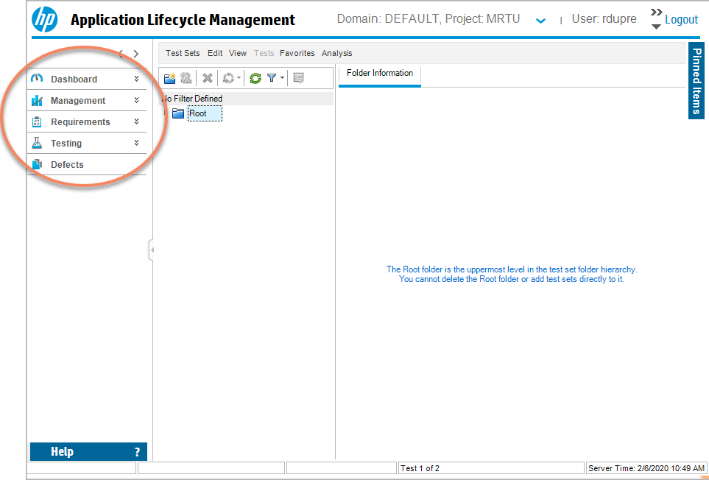

Each view has a series of folders to help organize the testing process. The first step is typically to add the BRS requirements into the Requirements module. Requirements explain what should be accomplished to meet the objectives of the project. The requirements for testing come directly from the Business Requirements Specification (BRS) and the System Requirements Specification (SRS) documents for a project or release. Testing is performed based on the requirements and test cases follow a similar naming convention as the BRS and SRS documents.
The Quality Center Requirements View is organized using the Release name as designated in Project server. Subfolders are then created for each of the Projects with the release. Note that the system is also capable of tracking smaller “Non-projects” efforts that might represent an infrastructure change or set of defect repairs.

When a requirement is written in the BRS or SRS, the Project Test Lead is responsible for uploading the Business Requirements from the BRS to the Requirements Module.
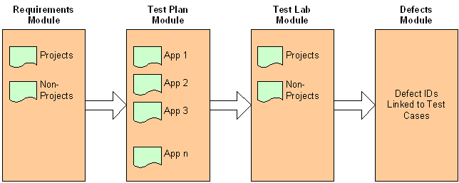

The next step is to create a Test Plan which will contain Test Cases that support proving out the requirement. Thus, Test Cases always need to be linked back to a requirement. The assigned testers are responsible for linking the applicable requirements to test cases. A Requirements Coverage metric is used to indicate if all Requirements are covered by one or more test cases.

The Test Lab is the module used to run and record test case executions. A Test Case can be run repetitively until it has passed or rerun to support regression testing.
The Defect module records issues that are normally the results from failed Test Cases.

Quality Center Testing Tasks

Creating a Test Plan

Clear and concise test plans are key to successful application testing. Test cases are created under the Test Plan folder. To navigate to the Test Plan folder:

- Select the Testing Tab.
- From the drop down menu, select Test Plan.

The root folder for each test case is located in the test plan by application name.

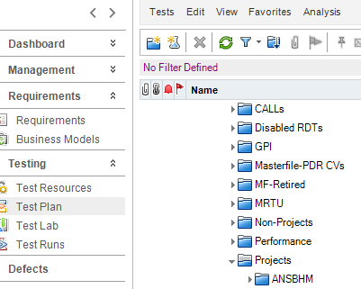
The folder structure in the Test Plan module is organized by application and each application folder contains additional subfolders as in the example above. The subfolders include Project or Non-Project (CRs) specific test cases.

Note: Once the Project or CR is implemented the base Test Cases are updated to include the latest requirements. The base Test Cases should always reflect the latest production release.

Note: The project and non-project test cases are preserved for historical tracking purposes. Test Cases no longer being used can be moved to the retired folder and the Test Case status changes to retired.

.

Uploading a Test Case

Test Cases can be uploaded to the Test Plan folder two ways. Use either the Test Case template method or the manual upload method.

Uploading a Test Case Using the Test Case Template

To upload test cases using the test case template:
- Request the HP ALM Upload Add-in application for Excel.
- Open the Excel application.
- Click the Quality Center Upload Add-in tab.

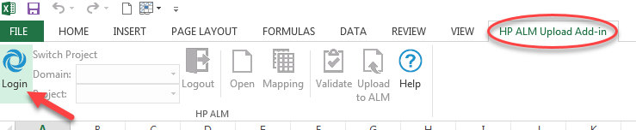

- Log in to the Quality Center Desktop Client using these log in instructions.

Quality Center server URL link to Quality Center
- Once logged in, click Mapping.
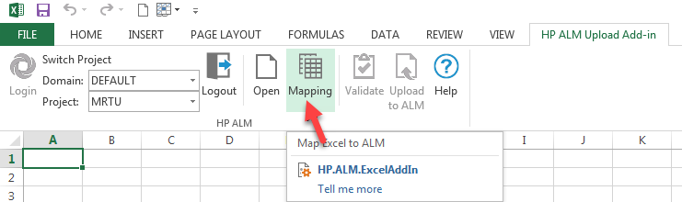

The Quality Center Excel Add-in – Field Mapping window will appear.

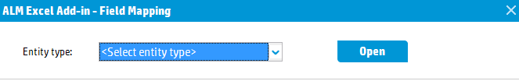
- Select Entity Type: Tests

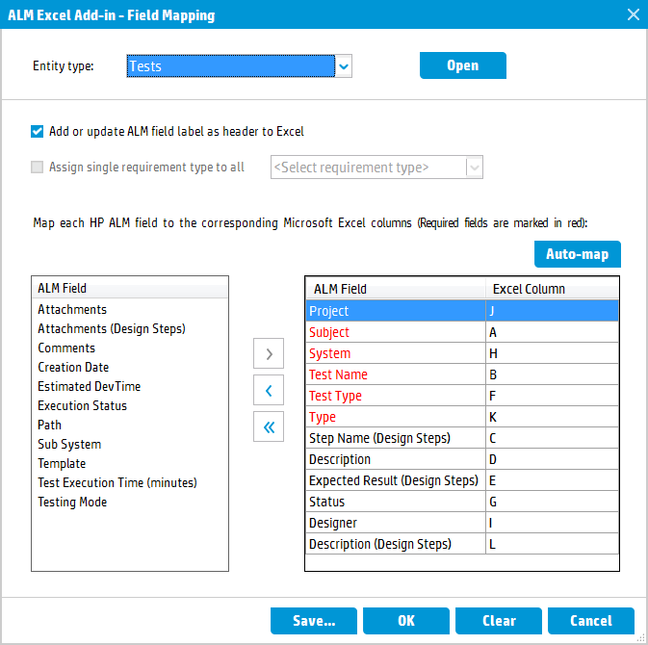

- Map the Quality Center Fields (red are required) to the desired lettered Excel Columns.
- Click Save.
- Highlight the desired Test Cases.
- Click Validate.
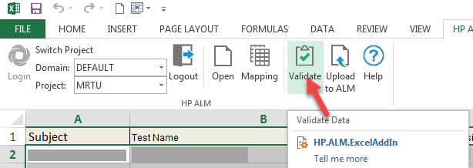
- Click Upload to Quality Center to upload the Test Cases.
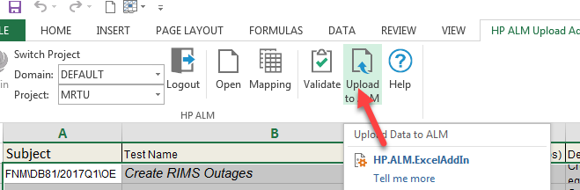

Create a Test Case Manually

A test case can also be created manually.
- Navigate to the Test Plan tab and locate the application folder.
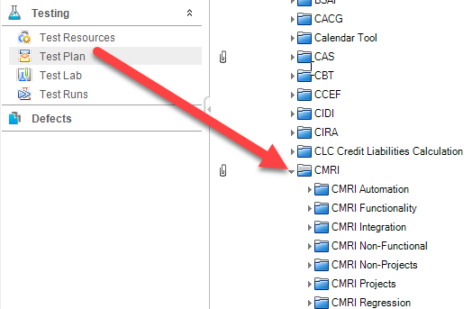
- Click the application folder. (* Test Lead will be creating the project folder and the tester will create the testing folder)

- Click New Test.
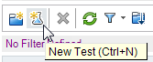

- Complete the required fields in the New Test form:

  - Test Name
  - Type: Manual
  - Project
  - Test Type
  - System
  - Description

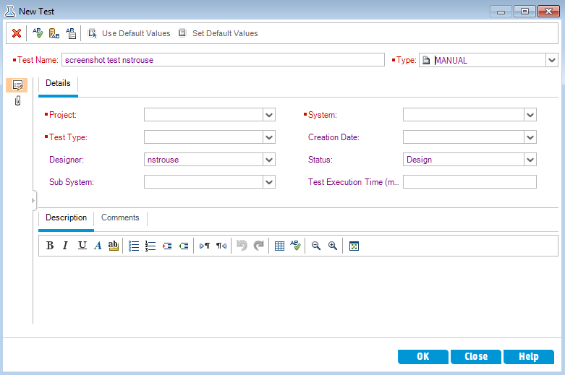

- When the test case has been created, click Design Steps.

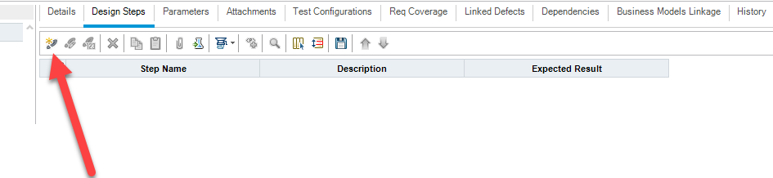

- Create steps by adding the Step Name, Description and Expected Result.

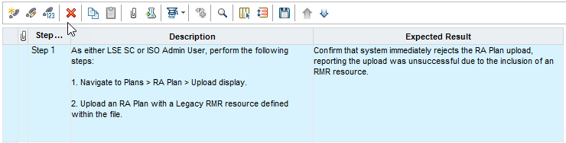

Note: When creating a test plan, test cases cannot contain the following characters: \/:%'*?<>|".

- Characteristics of Good and Bad Tests Cases:
Good Tests:
- Has clear instructions on how & when to run it.
- Provides good isolation - if it fails you know where the problem is!
- Is based on the requirements not the implementation.
- Is maintainable and has good tractability so that if the specification changes you can quickly match it.
- Tests the most significant behavior first.
Bad Tests:
- Is undocumented or can only be run by the expert.
- Is based on the implementation not the requirements.
- Tells you that there is a problem but not what or where.
- Takes a long time &/or has a high cost.
- Sometimes passes on bad items &/or fails on good.

Additional Test Case Development Guidance
Before beginning test development confirm requirements are clear, unambiguous, and testable. Seek requirement clarifications if needed. Avoid assumptions.
- Tests should focus on discrete features or functions. The steps should not be too expansive in scope and the overall test should only exercise one thing.
- Avoid tests with multiple functions and multiple expected results.
- Avoid steps that are obvious and do not add value (i.e. user logs in, log in page displayed)
- Test prerequisites are clearly defined (i.e. test data, roles, etc.).
- Test steps include clear expected results.
- Avoid steps that cover the use of testing tools (i.e. launch OIM Lite to find a cert, SOATest to submit or retrieve)
- Leverage all deliverable documents to define tests and steps (i.e. SRS, SADS, DDS, RRS, MDD, and Interface Specifications).
- Consider edge cases and exception handling as separate tests. These are very important since most developers do not test these!
- Include validations of underlying data. Don’t assume that that since the data presented on the UI matches the data in the database that the result is correct. Refer to the data source or other business rules.

Preparing for Test Execution – Link Requirements

The first step is to make sure that the Test Case you developed or uploaded, is connected (or associated) with a requirement. Each test case (Functionality, Integration, Performance and Security) should be linked to a requirement and a requirement can be linked to one or more test cases.

In Quality Center, a non-linked test case looks like the image below. Note the status of Not Covered in the far right.

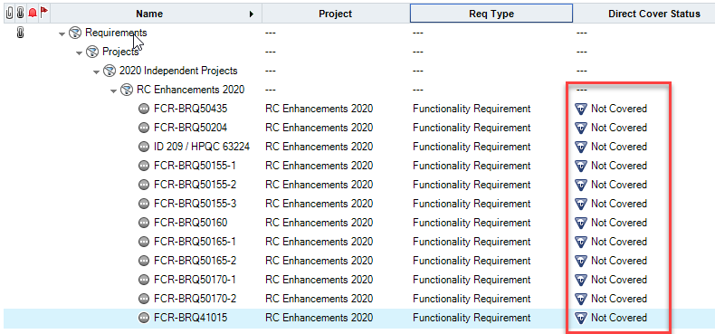

Link the requirement using this procedure:

      - Navigate to the Testing Module and Select Test Plan.
      - Navigate to the Test. Remember they are organized by Application.
      - Select Req Coverage.
      - Navigate the right Requirements pane and select the Requirement. Remember, they are organized by Project.
      - Select the green arrow to link. Success!

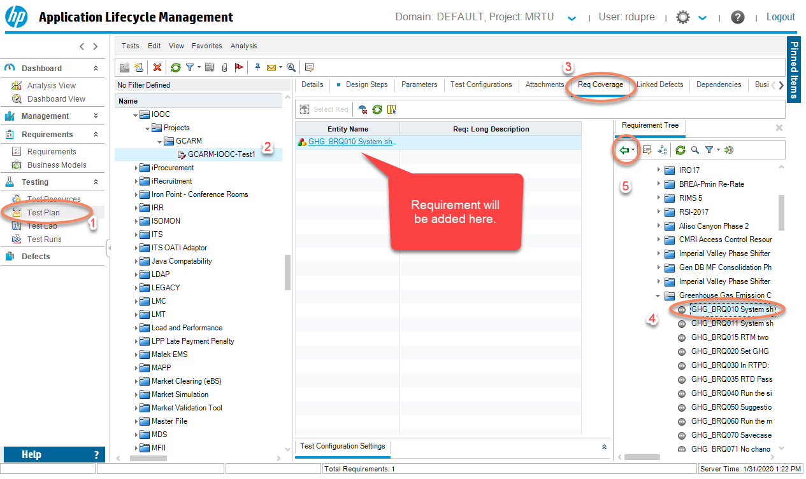

Note: You add multiple requirements in one move by selecting more than one requirement before linking.

Once the test case is linked, it will be in a No Run status. Note that after a Test run is attempted (see next section), the status will change to Passed, Blocked or Failed.

Note that the Test Plan module is organized by application but the Requirements module is organized by project. Thus for full coverage, all apps impacted by a project must have requirements linked with the exception of Regression test which are a special use case.

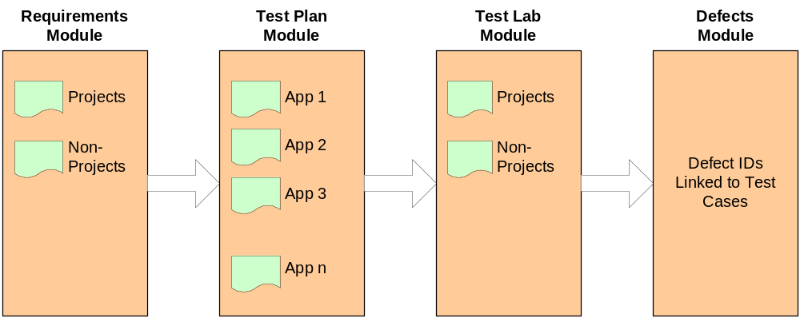

Note: If a test case needs to be deleted, cut and paste it to the ZZ trash can folder. Only administrators have delete permissions.

    - Preparing for Test Execution – Move Test Cases from Test Plan to Test Lab

After the Test plans are created, link the requirement using this procedure:

      - Navigate to the Testing Module and Select Test Lab.
      - Navigate to the Project.
      - Select or Create a Test Set which allows you to group tests into smaller chunks. Note that there is a New Test Set option under the Test Set menu).
      - Navigate the right Test Plan Tree pane and select the Tests from the Test Plans.
      - Select the green arrow to link. Success! You have now created a copy of the Tests that you will execute against.

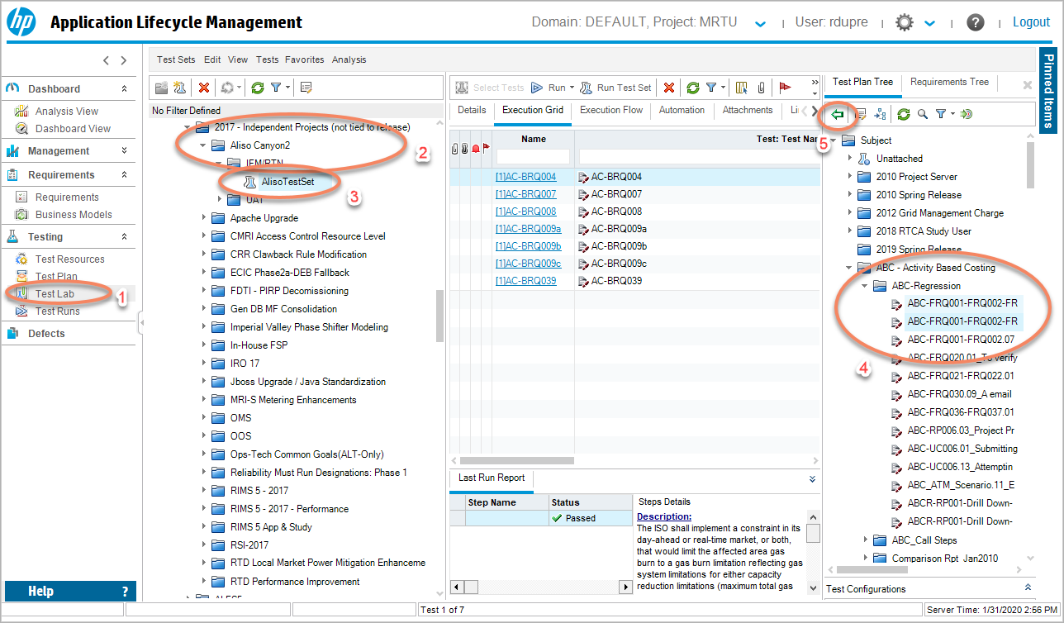

Executing Tests in the Test Lab

Your objective is to find defects and fail tests! This may seem surprising but it creates a better product for our customers. Anything less in terms of effort and objectives is a disservice of the entire testing process and creates the impression that the software is more reliable than it really is. Testing is the last defense before our customers experience our software to finding software issues, and upholding our reputation.

To execute a test case in the Test Lab module:

- To execute a test first select the test set then select the test from the execution grid and click run.

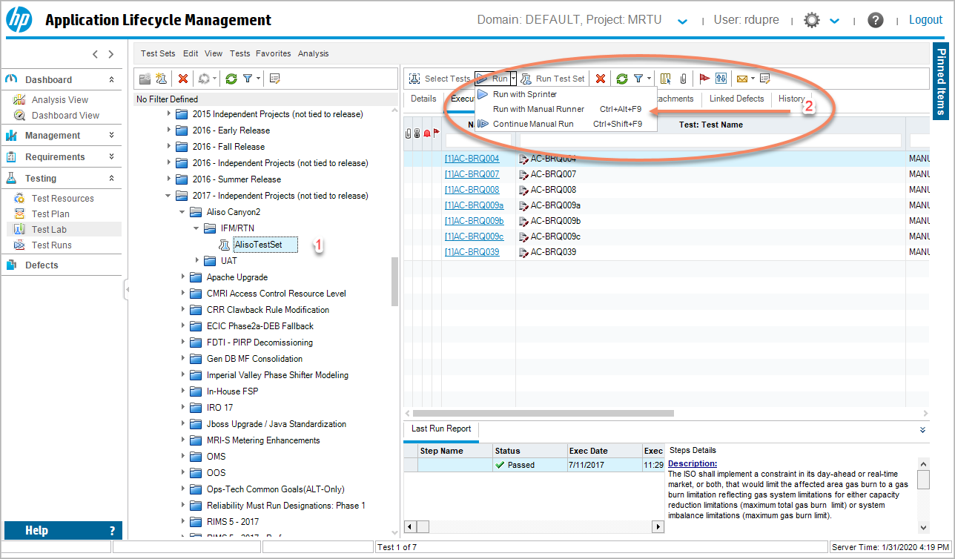

The manual runner will launch. Click Begin Run and execute each test step. Record actual results in the lower right panel of the manual runner for each step. Include any attachments as applicable.

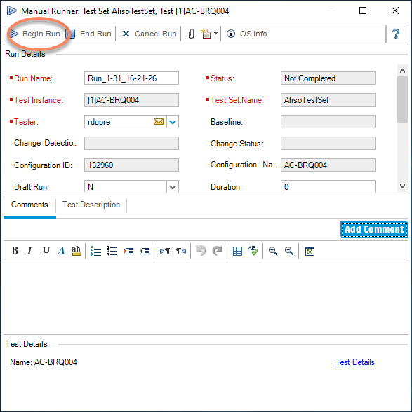

- Update the step status from No Run to either Passed, Failed, or Blocked. Note that if one step in a series fails, is blocked, or has a no run status, then the whole test case fails which is a correct action.

If the test is failed, create a new defect directly from manual runner. If the test step cannot be completed, update the step status to blocked and add notes in the actual results panel to indicate why the test is blocked.

- If the actual results are consistent with the expected results set the step status to Passed When the test case has run, Pass or Fail will appear.

- If the test case fails, link it to a defect.

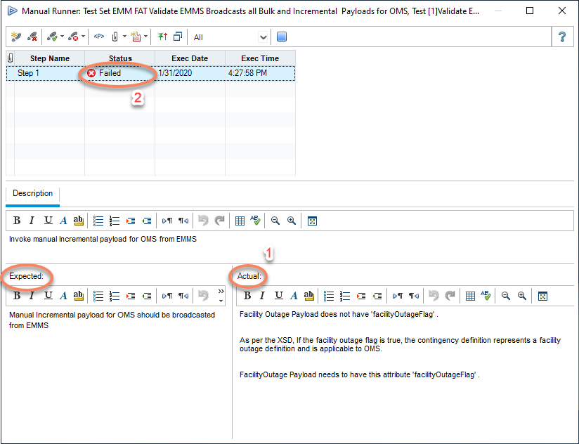

Expected and Actual Results Guidance

- If the software fails after release, it is possible that the test cases will be forensically examined to determine if we tested the failed condition. Your notes are crucial to this investigation.
- If possible, copy and paste the test results from the application under test.
- Alternatively, manually enter the observed result for each step in the actual results area. Describe it thoroughly!
- Include screen shots and other test results as attachments when appropriate.
- If saving a data file as evidence, reference it’s accessible location and note that it must remain available for the entire retention period which will likely be years.

Step Controls

If you forget to enter an actual result for a step (3) and try to pass the test (1) you will be presented with the dialog box below. Simply click OK (2) and enter the Actual result. You will then be able to end the run (4). The same applies to the Description and the Expected result.

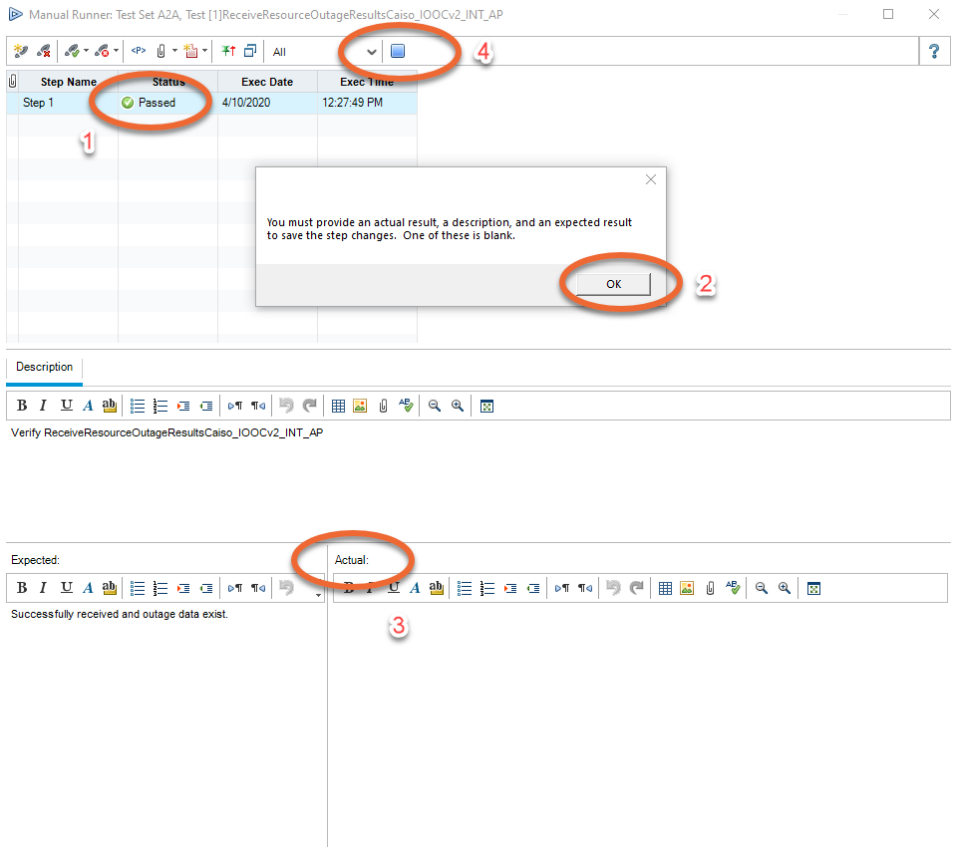

Example of a Passed Test
From the Test Lab
- Click on the paperclip to add an attachment such as a screen shot.
- Sample screenshot which is being added in the figure below.
- In this example, the user type is identified in test description. Important for role testing.
- Expected result is clear and specific.
- Software version under test is noted.
- Comments refer to attachments which further support the test results.
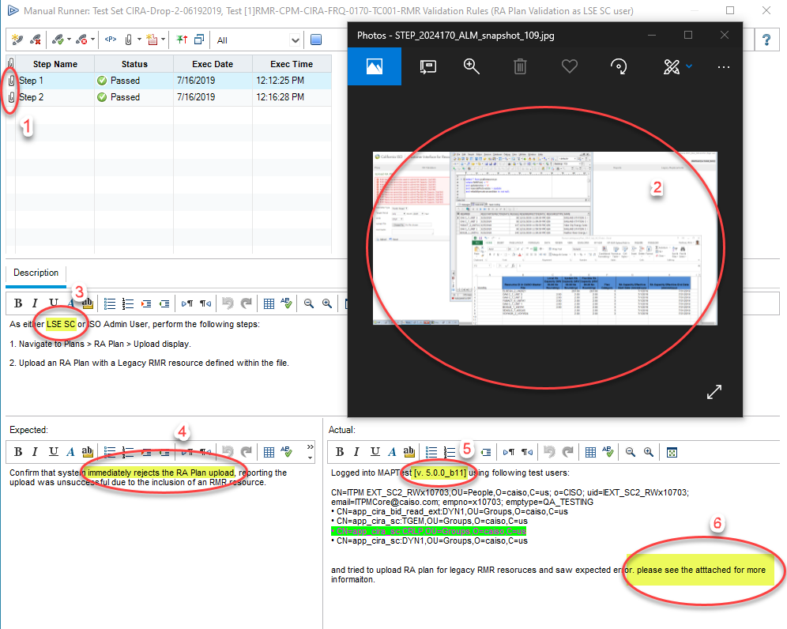

Example of a Failed Test
From the Manual Runner
- This assumes a test step failed (the overall test status will automatically reflect failed too)
- Click on the paperclip to add an attachment such as a screen shot.
- The expected result is clear and precise.
- The actual result is given with details to allow development to further diagnose the problem.
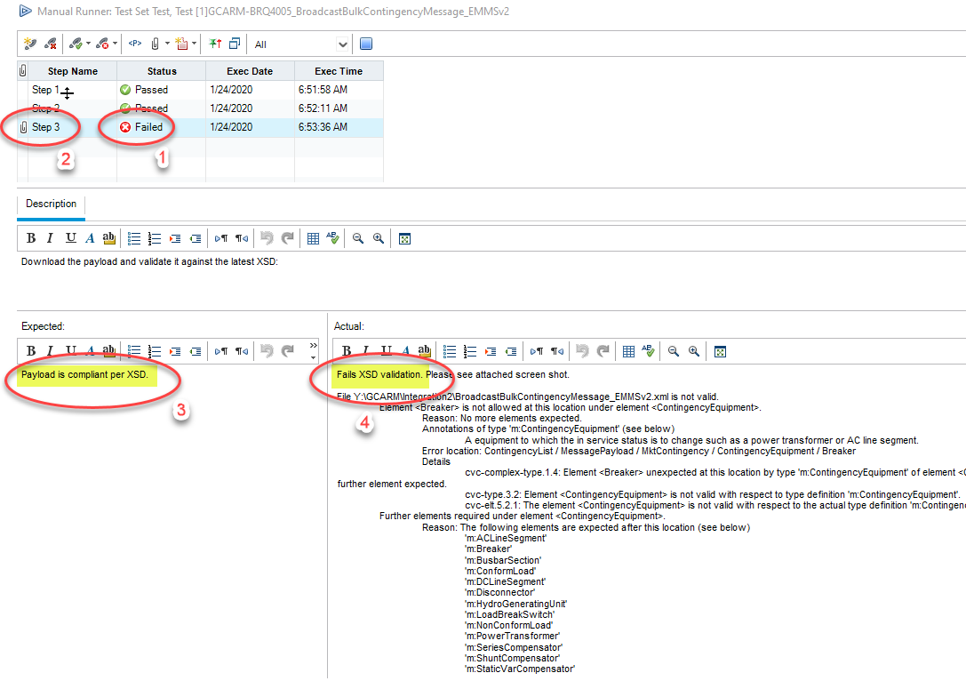

Defects

Creating/Linking a Defect to a Test Case

If a defect is detected, a new defect should be created and linked to the Failed test case. The Defects window will allow the following key items to be recorded:

Field | Value
Assigned To | Who will fix or triage the issue?
Defect Type | What type of defect it is? Refer to the Test Management Guidelines for Defect type values.
Detected by | Who detected the defect?
Environment | Where did it happen? Map Test, Test, Map Stage…
Priority | How soon should it be fixed?
Project | Project Name
Root Cause | Why did it happen (if known)?
Severity | Severity is dictated by the amount of functionality which is broken based on the requirement and the testing phase. Refer to the Test Management Guidelines for severity definitions.
Status | NEW
System | Which system or application?
Test Phase | FAT, functional, UAT, etc
Vendor | Who, if applicable, is the vendor?
Version | Application version

Note: Defects are not linked to requirements. Defects are linked to Tests Cases.

Note: A Compliance defect is a direct result of FERC compliance.
A Dispute is a direct result of a valid SDS dispute entered in CIDI.
In case a defect impacts both types, it should be marked as a Dispute.

Steps to create a new defect:

- Select the failed step.
- Select Defect by clicking on the defect icon and menu will appear.
- Select New Defect. (Ctrl+N) The New Defect window will appear.
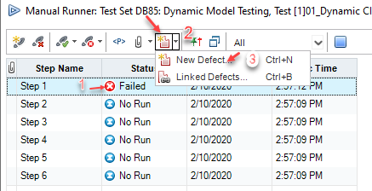

- Enter details (Red fields are required) with a detailed summary (and picture attachment, if possible) of the problem, an error message, and a script step.

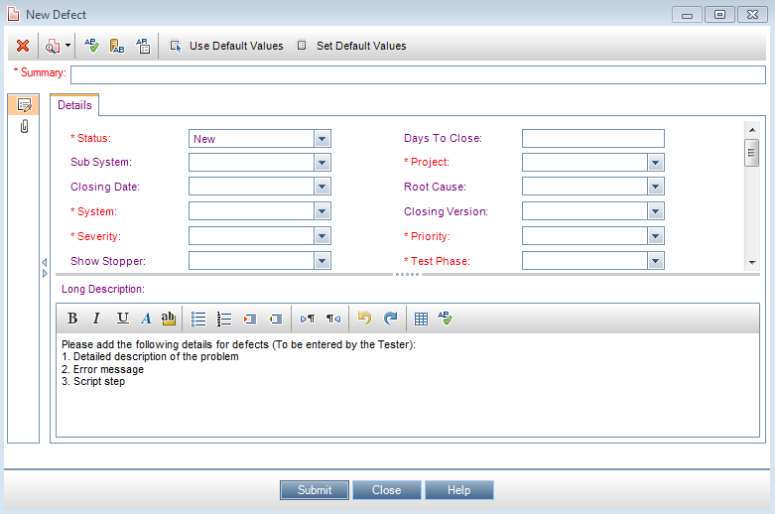

To link an existing defect to a test case:

- Select failed step
- Select Defect by clicking on the defect icon and menu will appear.
- Select Linked Defects. (Ctrl+B) The Linked Defects window will appear.

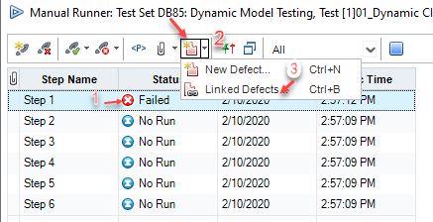

- Verify that you see the Run Step Details window.
- Click on defect icon and select “By ID”.
- Enter existing Defect ID number.
- Click the Link button.

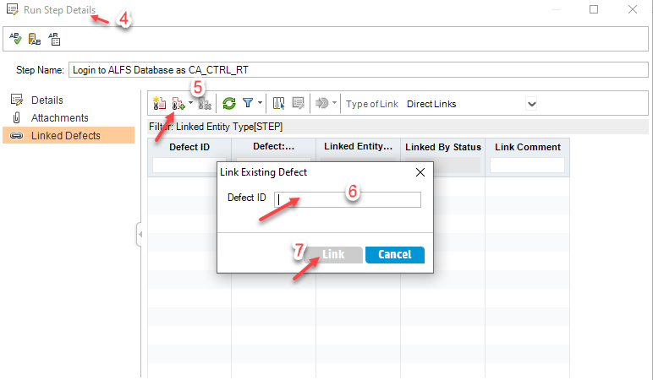

Defect Retest

Defects should be reassigned to the originator when the defect status has been set to fix. The originator should retest and close or reopen the defect as applicable. The related test case status needs to be updated as applicable.

To mitigate a new defect:

- Select the Defects tab.
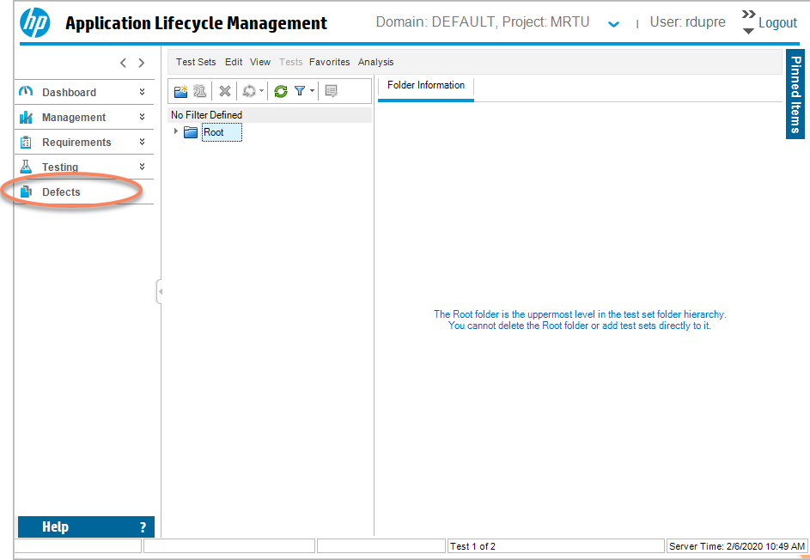

Finding a Defect

- Click on the Defects view
- Click on the Defects menu
- Click on “Go to Defect”
- Enter the Defect ID.

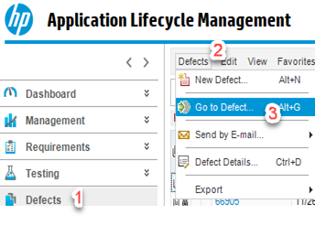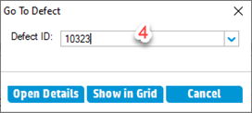

- Add Comments
- Add Attachment/evidence
- Update Defect Status
- Click OK.

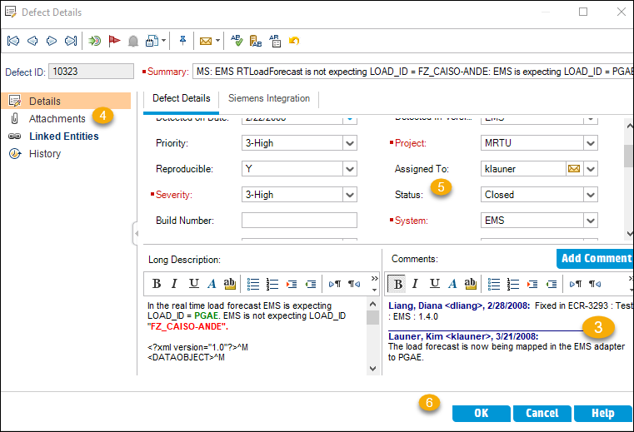

Dashboard

Analysis View

The analysis view allows the user to view the testing information in folders by project. Project folders contain defect lists and test status reports created by the test lead with details and descriptions.

Dashboard View

The dashboard view contains the details, configuration information, and graph view of the testing and defects. The testing details can also be filtered by Assigned To and Status.

For additional help with the Quality Center application, contact the CAISO Service Desk.

